An exercise circuit to stop a sendentary lifestyle in workplace environment

BS. Christopher Sanchez Coto
Universidad de Costa Rica
San Jose, Costa Rica
christopher.sanchezcoto@ucr.ac.cr
MSc. Gustavo Lopez Herrera
CITIC, Universidad de Costa Rica
San Jose, Costa Rica
gustavo.lopez_h@ucr.ac.cr

Abstract—Even with the amount of information and evidence of the adverse effects of not exercising enough, we continue having sedentary habits that in most cases are the tip of the iceberg for a much more broad number of diseases. In this paper we are going to propose a circuit of exercises to apply in the place where most of people send half of the day, the workplace. We looked for a series of exercises that involve most of the body, from the legs to the arms with different types of movements which can help reduce the stress levels and put our bodies in a state of activity.
Keywords—exercise, circuit, sedentary lifestyle, bad habits

Introduction
We begin defining being sedentary as spending excessive time sitting or in a reclined posture while participating in activities with an energy expenditure ≤1.5 metabolic equivalents during wake time [2]. Having an active lifestyle has proven to be one of the most effective ways to reduce the possibility of chronic diseases. The workplace is, in many occasions, were people spend most of their daily time, that’s why it’s important to develop a common culture to have an active lifestyle even in our daily activities in the office. 8 to 9 hours is the average work time by day for an adult, and according to recent studies [2] just a few people achieve even the minimum time of physical activity and spend excessive time sitting.
Obesity is becoming one of the major disabilities in the whole world and as mentioned before, the time people spend at the office might be a good starting point in order to decrease the sedentary lifestyle. Despite the large number of studies and recommendations, people are still having bad habits in their homes and workplaces regarding the physical activity they have to perform each day, and even they don’t meet the requirements for a whole week of minimal physical activity. Having sedentary behavior, even affect people that accomplish the recommended time of physical activity per week, that according to [3, 4] is 150 min of exercise.
Workplace is an ideal place to implement these exercises as it involves all kinds of people, some with sedentary behavior and some that exercise regularly. We are going to propose a series of exercises to be implement in the workplace environment, in order to reduce the sitting time and be able to introduce physical activity that otherwise wouldn’t be even considered by some of the people. The chosen exercises cover most of the main areas of the body we need to move/exercise in order to reduce the sitting time and stretching key points that will result in a better posture and will make our body to be in an active state.
Now days, even our watches remind us to stand up and move after several time of inactivity, we tried to propose simple exercises that don’t take a long time to be executed, they are focus in braking the sitting time and making the people perform small amounts of physical activity.
As indicated in [5] there is still some people which doesn’t take this as a serious problem in our society, we are trying to raise awareness and create a series of exercises that all of us can implement in our workplaces, that doesn’t takes us a lot of time and won’t interfere in our work activities, but will makes us active for periods of time during the day.
Studies [6] reveal that workplace is an important setting for physical activities promotion and initiatives, and a key place for addressing these issues. Although there are a lot of factors that are responsible for these types of problems, we try to cover most of the workplace environments, call centers, offices, stores, and in all of them the called “wok time” is even more sedentary than “non-work time”.as

Relateed Work
Several authors describe the importance of having good habits and insist to incorporate physical activity in a minimum of 150 minutes a week, creating a culture and understanding the bad results and dangers of having a sedentary lifestyle, most of the studies focus in gathering data regarding how much time people spend inactive vs how much exercise people do in their daily basis.
Proposing a single exercise, creating a guidance is the most look alike type of related work.
Gardner et all [5] having a guidance noticed much of the people were not sure about the knowledge or where the information was taken from. Confusion and misapprehension are some of the words used to describe the knowledge of people regarding these problematic.
Our approach includes a series of individual exercises to be implement in workplace environments, and a way, not to measure, but to know if people are performing the exercises correctly. One by one, the exercises will need to be followed, when finish with one, you go for the next and so on until completion. With nowadays technology, we have all the means to remind us the exact time we need to move, or to stand up after a long period we had sitting, we want to define a circuit that people need to perform.

Circuit overview
Our circuit consists of a set of 4 exercises that need to be performed one by one. For each one of these, we will have a sensor or a set of sensors, depending of the exercise, to detect the movements required for each one successful completion. In Fig. 1 we have the conceptual model of exercises set, not in any particular order as they can be performed as the user wants to.

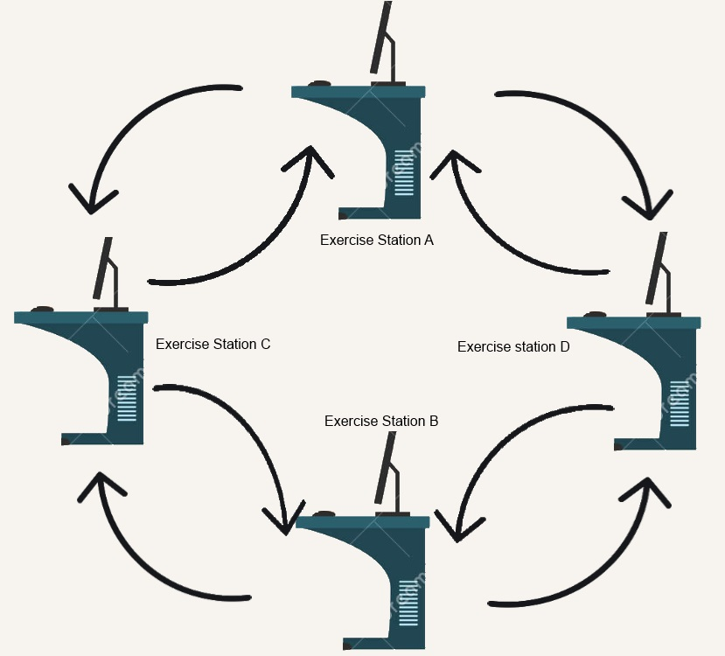
Fig 1. Exercise circuit conceptual model

Exercise Interface
The interface that we use consists of an application that indicates the exercise that must be performed in each station. The application shows an image with the exercise to be performed in every station and provides a log with the information and set of events the sensor is receiving. Also provides the user with the exercise messages. We will take a deeper look at the application shortly

Set of exercises
The set of exercises we choose can be performed but most of the people and should never make the user feel any kind of pain and discomfort, at any time that the user experiences some severe pain or out of the ordinary the exercises should stop at that moment, the exercises can be identified by a touch sensor that is positioned in the exact location of every station or exercise, some of them in the desk, other in the chair in different positions, that way we can have the user be in the correct position and executing the tasks in a correct way. Several touch sensors where are used for some of the exercises.
The idea of using the items we have at the office, chairs, desks, is to integrate the sensors without being intrusive in the environment, so everybody can continue their daily activities and just go to the station when needed, this way we don’t have the need to install or bring to the office any device, everything you need is there and the exercises are very simple for everybody to perform without any excuses.

Interface Implementation
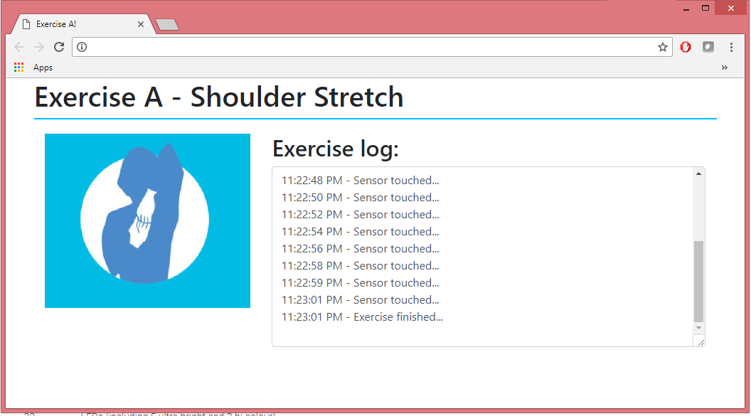
Fig 2. Application Interface

Our implementation is based on the Phidgets Touch/Human input sensors. The application was created using a simple HTML and the Phidgets libraries that we control through JavaScript. Fig 2 shows the basic interface for exercise A in particular, the interface is the same for all the exercises we are proposing here. On the left side of the application is the image for the current exercise, on the right hand there is the log field that will contain all the information of the events received from the sensor. On Fig. 2 we can see how the log field works, showing that the sensor was touched several times in a row and finally a message indicating the exercise is finished.

In this case, the interface is working for Exercise A that requires only a single sensor, as we will explain in detail shortly, if the exercise requires more than one sensor, the application will show which sensor was pushed at any given time, as well if the user performs the exercise wrong the log will show an error message and a pop-up window will indicate the user about the wrong event received from the sensor.
The very first screen of the interface is just a list for selecting the exercise to perform in that particular station, this allow to execute all of the exercises in any of the stations, the only requirement is to have the required sensor or sensors needed to that exercise. Phidgets provide libraries for different technologies like Java, C, C#; JavaScript was selected in order to be able to create a web application that can be seen from a more broad number of devices like computers, cell phones, tablets and any device with a web browser.
The sensors chosen for the physical implementation are the Interface Kit and the Touch Sensor we can see in Fig. 3, however the user will only interact with the touch sensor, the interface is only for providing the necessary logic for

Fig 3. Phidget Touch Sensor

the sensor to be able to recognize inputs and send them as messages to the libraries we are using. The Phidgets provide a wide number of sensors to be used in various applications among which we have touch sensors, such as in this case, slide sensors, rotation sensors, gyroscope sensors, among others.
The only requirement for the application to run is to have the Phidgets Control Panel running on the computer, and there we have 2 options, the first one to use the current computer as the main device for the Phidgets, the second one, and the one we chose, to be able to create a Network server to work with JavaScript, the Network servers need a host and a client, the host is the computer where the Phidgets will be physically connected, the client is the computer from where we are going to open the application, for the purpose of this paper, the host and the client will be the same, so the sensor will be connected to the same computer from where it is going to be tested.

Exercise implementation

Exercise A
This exercise stations is focused for the upper part of the body, the shoulders and the arms is one of the places where more stress can be cumulated resulting in disconformity and illness as well as some posture issues that will be very painful and difficult to correct if it is not taken in consideration when needed.
In this station, the user has to raise his arm and put it behind his back and touch a point for 15 seconds for each arm, with this set of movements we will be stretching the shoulders and the arms. The idea is to stretch the muscles as much as possible and be able to reach the sensor that is located in a specific position.
15 seconds are required for each user input to complete successfully one set for one arm, if less than 15 seconds are indentified, then the application will show a message to the user indicating that the elapsed time doesn’t meet the expected time, so the exercise needs to be executed once again. In this implementation one we olny have one sensor, so we have to rely on the user to use both arms to complete the task.
It is very important to adopt a correct posture at the time of performing the exercise, a good posture will enable a very confortable position and a very easy exercise as the arms reach will be the necessary to complete the steps. If the posture is not the correct the user might be facing issues reaching the desired point where the sensor will be located.
The software implementation for this exercise is an application that captures the events received from the sensor. The expected set of events is the user input into the touch sensor for 15 seconds, several times for each arm, showing the image and a message box for each input it recognizes. If the time the user pressed the sensor is not the expected 15 seconds, or the sensor has not been pressed for 30 seconds, the application will be notify that the exercise is not being performed correctly and should be restarted. At any time of the task, an image of the exercise will be in the application screen, this will apply for all of the exercise stations we are proposing.
The physical implementation is a touch sensor in the back of the desk chair which senses the user input, gets captured by the software and then shows a message in the screen, wheter it is a successfully completion or an error from the user. The user needs to perform this several times to complete the station and move to the next one, 5 times per arm, 15 seconds each time the sensor is pressed. Only one sensor is used in this exercise because only one arm at a time will be needed and both arms need to reach the exact same position.
The idea of using the chair as the main device in an exercise station, is to use everything we have in the workplace environment and it is a natural position that will create no confusion at the time of the exercise execution. The chair is an item than can have a much more broad approch to the people wellness, as some studios already indicate, the correct posture can be the reason for many of the back pains.
The chair is sometimes the place where we spend most of the time in our daily activities, so it is a good idea to implement this exercise in the chair with a natural position for most of the workplace environments. This could also be accomplished in a standing position but the chair is perfect so we can put the sensor in the correct spot to identify the users movements without the need for the user to wear any special device to input the arm movement in the back.

Fig 4. Shoulder strech exercise

Figure 3 shows the basic idea for the arm movements, where the user needs to reach his arm to a certain position in his back in order to complete successfully the exercise. In that scenario, both arms are in the back, but we are going one by one so the touch sensor can identify the user input for each one of the arms.

Exercise B
The exercise for this station is focused to the legs. Being in a sitting position for a long period of time affects the legs in ways we might not image, we need to have activity for the blood to reach every part of the body, and sitting brings pressure to the legs making it difficult for the blood to transit there. Executing a single exercise can activate the blood flow in our legs and to a long term, giving us a much more strong and healthy body. Excessive sitting with no physical activity is a real problem and can bring much more issues than people are aware of.
One by one, sitting in the chair, the user has to raise his legs until reaching certain position where is able to touch a sensor. The legs should start in the normal and correct sitting position, and raise one leg to a horizontal position, then the other one. When each leg gets to the horizontal position, user should able to reach the located sensor for this task. In this exercise we introduce the desk as an exercise item as it is a key asset for every workplace in almost any kind of office and/or workplace. This exercise needs several touches of the sensors to be completed successfully. Same as the previous exercise, it is very important to be sitting in the correct position to raise the legs without putting pressure to the back.
In this station, is not needed to press the sensor more than one second, just a touch and the user should be ready for the other leg, another variant of this exercise can be keeping the legs in horizontal position for a period of time but in this case is enough to be able to reach the desired position. This exercise has to be performed taking the necessary time to raise the leg without hurry, performing this or any exercise with a hurry can result in not doing the exercise correctly.
The software implementation for this exercise is similar to the last one, but this time we have 2 sensors. The same, the software needs to recognize user inputs from different sources, in this case one sensor for each leg as they are not supposed to reach the exact same position, there is one correct position for each leg. The software waits for the user to make the inputs, once the first touch sensor sends the event, the application waits for the other sensor to be pressed. If the same sensor is pressed twice, the application will show an error message indicating that the same sensor was pressed more than once time and will indicate that the exercise needs to be restarted.
For the completion of this exercise station, the user needs to touch the sensors 8 times with each leg, alternating between the legs for every touch, so at the end 16 times should be the end of this station. Depending on the user physical state, the amount of repetitions can increase or decrease but we are proposing the exercises so anybody can perform them, regardless of their physical condition.
Physical implementation involves the chair and the desk to place the sensors. We are using the chair once again and now introducing sensors to be placed below the desk. The sensors should be placed at the exact position where the legs in horizontal position reach, this way it is very simple for the user to perform this correctly without any pressure or discomfort. The desk is a broad area to put sensors, we tried to incorporate as much office equipment while still maintaining a good workplace environment without any kind of interruption or annoyance.
Another sensor can be incorporated in the chair in order to determine if the user is sitting and in the correct position with the correct posture, but for the purpose of this paper, we are only using the sensors to determine if the user is able to reach the indicated positions with the different parts of the body. Although is very important to adopt the most comfortable and correct position while performing the exercise.

While we perform this exercise we can adopt the correct way of sitting, even though the current office chairs have characteristics that require good posture, it is important to remind us through exercises that a correct way to sit can provide many benefits in the short and long term, as to prevent future problems, just as it is to have physical activity with our legs.
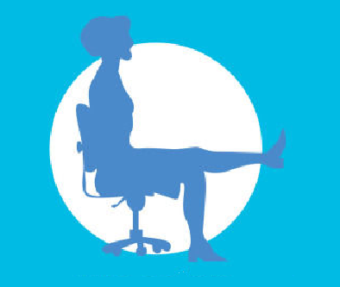
Fig 5. Leg extension exercise

Exercise C

In this station we are going to perform the spinal stretch exercise, again this is going to be executed sitting in the chair. We already mentioned the benefits and how important it is to adopt a correct posture when we are sitting, especially in our workplace as we can spend there most of our day and long periods in the same position can result is serious problems if our way of sitting is not the correct one, and our spine suffers directly the impact of a bad sitting position.
In this case, we focus in the spine, as it is a very important part of our body because it is the support point for our posture and our entire body when sitting, standing, at any time. The spine keeps the muscles and bones aligned correctly and this way the risk of having muscular or related to our bones.
If the spine is not in the correct position it can be affected and we will start experiencing symptoms as fatigue, muscular pain that will not only affect our back, but other parts of our body as well as many of the nerve endings go through the back and are attached to muscles and our spine because it is a support point for our body, without forgetting it contributes to a good personal appearance.
A lot of factors can affect our spine and specially our spine, things as simple as sitting with our wallet in the pants. Using our wallet while sitting puts pressure in the back and doesn’t allow to be sitting in the correct position, one of the legs will be higher than the other and this results in our spine not being perfectly straight.
The exercise for this station will contribute directly to the spine, releasing pressure that might be generated there, with a simple movement is possible to relax and strengthen the muscles so that they can remain in an optimal state for all the activities not only in our workplace, but in all the daily activities.
We begin this exercise sitting in the chair, again sitting with the correct posture looking straight forward without making any movement or turning our back. Next the user needs to turn the upper part of his body, trying to not move from the chair, first turning to the right y reaching with the hand the sensor that will placed in this station, next return to the initial position looking straight forward by turning the upper part of the body, again without trying to move the legs and keep sitting correctly. Now turn your body to the left the same way until reaching the sensor that will be placed on the left side and finally returning to the initial position once again.
This set of movements must be performed 8 times in each direction in order to complete this exercise correctly. For this station, 2 sensors are used, one for each side, left and right from where we are performing the exercise, we put the sensors in the desk for it is a natural height for the user to reach with the hands. The user only needs to reach the sensor and touch it. If the application detects the same sensor has been touched twice in a row, the user will see a message that the exercise is being performed incorrectly, the idea is to stretch the muscles connecting to the spine moving from one side to another.


Fig 6. Spinal stretch

In Fig. 5 we can see the basic idea for this exercise, turning the upper part of the body while sitting on the chair, the legs in the correct sitting position and the sensor should be touched with the hand when reaching to it. This exercise can\ be performed standing, but in this case the desk results perfect to put the sensors in a perfect position for the user to reach them without an extra effort, more than execute the exercise.

Exercise D
For this last exercise station, we selected an exercise that not only includes the upper part or lower part of the body but both of them will be needed. However, this doesn’t mean the exercise is very complicated o way too difficult for the user to execute. The reason for this to include the whole body, is because the upper part is going to work as support for the body meanwhile the lower part, in this case the legs and specially the knees are going to perform the movements. With this exercise we complement by using the arms, in the previous stations, the muscles form the arms are not used in a big way.
Previously, all the exercises we proposed until now, are performed sitting in the chair, with this one we are going to make the user stand up in order to be able to execute the movements correctly. Standing up in the office is one of the most used practices these days to stretch and release some stress, even in many occasions it is recommended to take a small walk between sittings for a long period. Stand up is very important, so much that now the office desks allow the user to work in a standing position.
With this exercise we complement by using the arms, in the previous stations, the muscles from the arms are not used in a big way. In time the suppliers have adapted their products to the new requirements, although is not required, right now there is a strong trend to use office equipment that fits all the needs from the users, ergonomic. Some workplaces even have an occupational health specialist that is responsible to provide solutions in the workplace that correspond in this case to the equipment used. The employee can indicate there is discomfort or any kind of problem or issue with the equipment and the responsible department will evaluate the situation to provide the necessary tools.
In order to perform this exercise, the user must be standing and have to walk away one step from the desk, put the hands in the desk border without moving from the initial position. A knee flexion movement must be performed to be able to reach the sensors that will be place in the lower border of the desk, these sensors are responsible to detecting the user movements by sending the signal when the user touches them with the knees in order to complete successfully the exercise.
In this case, we are also sing 2 touch sensors, one for each knee, the movement can suggest us that the point to be reached is the same for both knees, but the movement must be performed moving the knees straight forward, this way the knees are not going to reach the same point, this is why 2 sensors are required for this station.
We could use sensors to mae sure the user is adopting the correct position, with the hands where they need to be, but in this case as we already mentioned, we focus on detecting the movements the user have to perform, we must trust the user is following the instructions for each station to be placed in the correct position or with the correct posture when corresponds. For the previous exercises, the user have to be sitting in the chair in front of the desk, this station differs from the other ones as the user has to be at one step distance from the desk and standing up.
For this station, the application works the same as the above exercises, logging the events in a window by the sensor and if needed showing the error if the user is not performing the tasks or the movements correctly. For this one, it is not necessary to keep the sensor touched, only needs to detect the event and send it to the application.
To complete this exercise station, the user have to raise his knees 8 times each and reach the corresponding sensor. If the application detects a sensor to be touched twice in a row the user will be notified of the failure y has to start again. Fig 6 can give us an idea of the correct position that must be adopted not too far from the desk but enough in order to be slightly reclined to put the hands in the desk. Only by adopting this position, the user will notice the whole body will be part of this station, and not only the knees that perform the movements.

Fig 7. Knee flex push ups

references

- Loitz, C.C., Potter, R.J., Walker, J.L. et al. Syst Rev (2015) 4: 178. https://doi-org.ezproxy.sibdi.ucr.ac.cr/10.1186/s13643-015-0166-4
- Sedentary Behaviour Research Network. Standardized use of the terms “sedentary” and “sedentary behaviours”. Appl Physiol Nutr Metab. 2012. doi:10.1139/h2012-024.
- Biswas A, Oh P, Faulkner GE, Bajaj RR, Silver MA, Mitchell MS, et al. Sedentary time and its association with risk for disease incidence, mortality, and hospitalization in adults: a systematic review and meta-analysis. Ann Intern Med. 2015. doi:10.7326/M14-1651.
- van der Ploeg HP, Chey T, Korda RJ, Banks E, Bauman A. Sitting time and all-cause mortality risk in 222497 Australian adults. Arch Intern Med. 2012. doi:10.1001/archinternmed.2011.2174.
- R. Nicole, “Title of paper with only first word capitalized,” J. Name Gardner, B., Smith, L. & Mansfield, L. BMC Public Health (2017) 17: 47. https://doi-org.ezproxy.sibdi.ucr.ac.cr/10.1186/s12889-016-3974-0
- Thor, A.A., Healy, G.N., Winkler, E. et al. Int J Behav Nutr Phys Act (2012) 9: 128. https://doi-org.ezproxy.sibdi.ucr.ac.cr/10.1186/1479-5868-9-128

